import java.util.Scanner;

class Student {
String usn, name;

void accept() {
Scanner sc = new Scanner(System.in);
System.out.print("Enter USN and Name: ");
usn = sc.nextLine();
name = sc.nextLine();
}

void display() {
System.out.println("USN = " + usn);
System.out.println("Name = " + name);
}
}

class StudentRun {
public static void main(String[] args) {
Scanner sc = new Scanner(System.in);
System.out.print("Enter the number of students: ");
int n = sc.nextInt();

Student[] students = new Student[n];

for (int i = 0; i < n; i++) {
System.out.println("\nEnter the details for student " + (i + 1) + ": ");
students[i] = new Student();
students[i].accept();
}

System.out.println("\nStudent information:");
for (int i = 0; i < n; i++) {
students[i].display();
System.out.println();

}
}
}

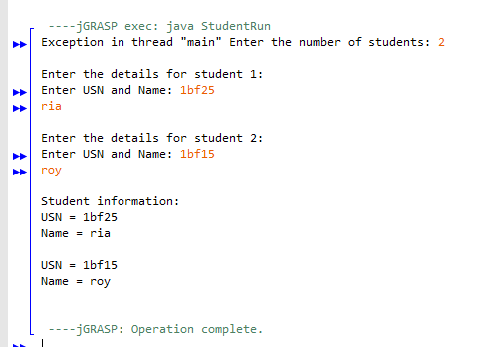1BF25CS138
Lalithya.K

